# Site Flow and Sketches

## Step 1: Competitive Analysis

|  |  |
| --- | --- |
| Competitor Site 1: <site name here> URL: https://facebook.com AnalysisWhat is good about this site?  1. You can share your image/video/post and see other people’s 2. Anyone can easily sign up and be a friend with others 3. Chatting/group feature makes user easily connect with other people.  What is bad about this site?  1. There are too many random posts that people either put/liked shown in my news feed 2. infinite scrolling make the user addicted 3. It can make you feel like your life isn’t as cool as everyone else’s | Competitor Site 2s: <site name here> URL: http://linkedin.com AnalysisWhat is good about this site?  1. The most important stuff is in the middle 2. Suggests people on the side of the page 3. The top is dedicated to relevant tabs that you need  What is bad about this site?  1. Sometimes too much information 2. Job related, has a serious nature. People may not enjoy using the website 3. It may lead users to feel mind-washed |

### Competitor 1 Pages

#### Page (or Screen) where you ask “find which company has most of your friend working”

#### Pages (or Screens) look for the answer

#### 

#### Page where you get an answer

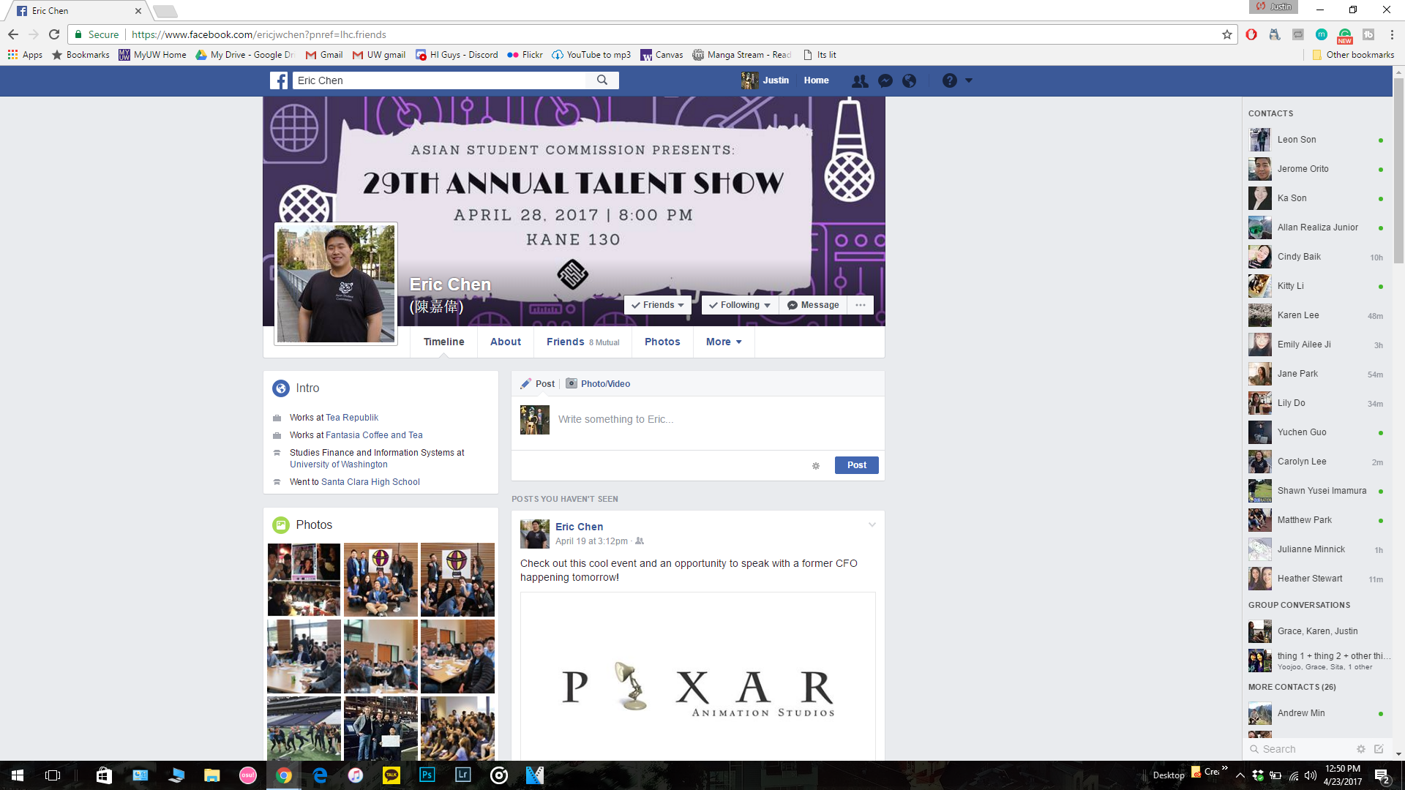

#### Repeat these step for more friends

### Competitor 2 Pages

#### Page (or Screen) where you ask “find which company has most of your friend working”

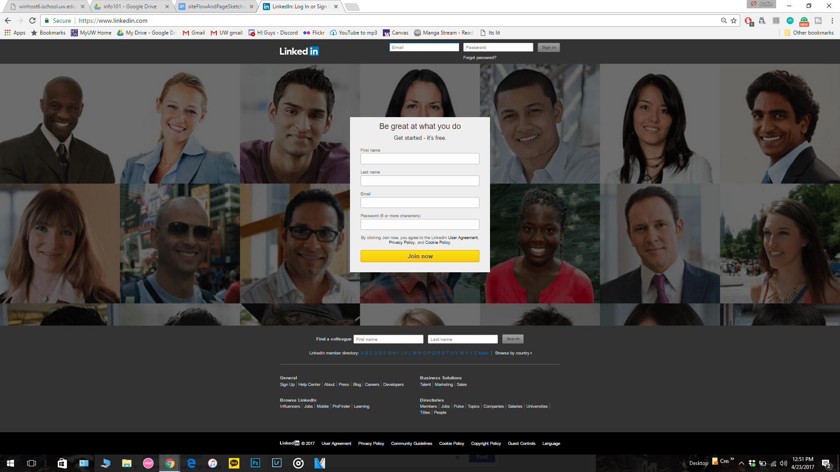

#### Pages (or Screens) look for the answer

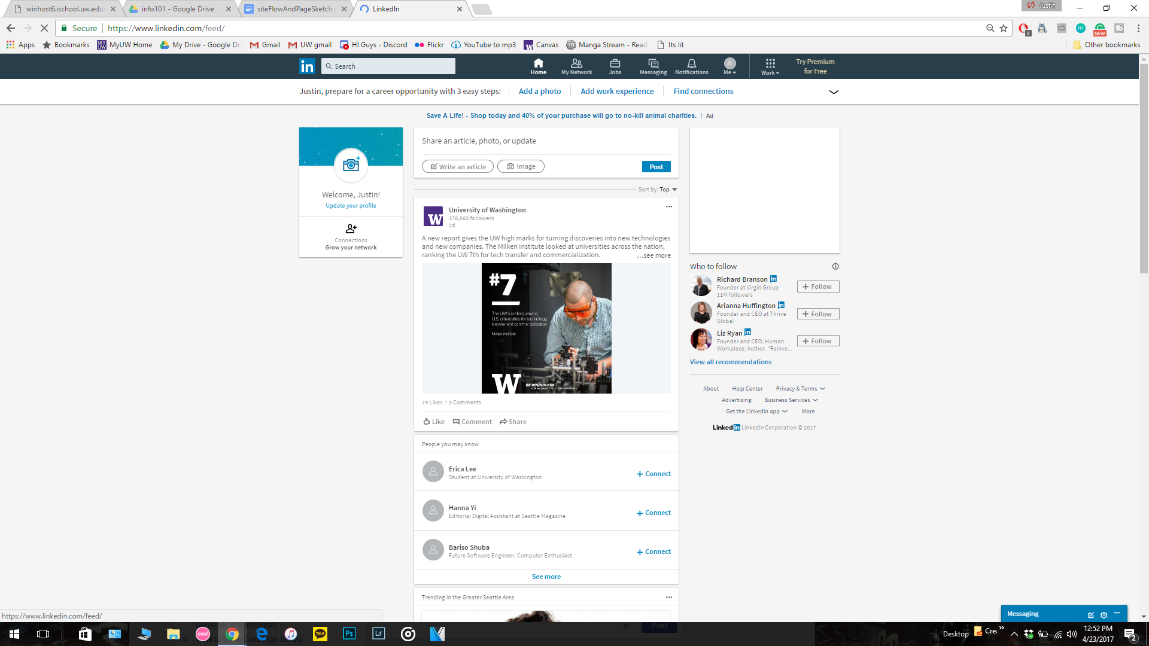

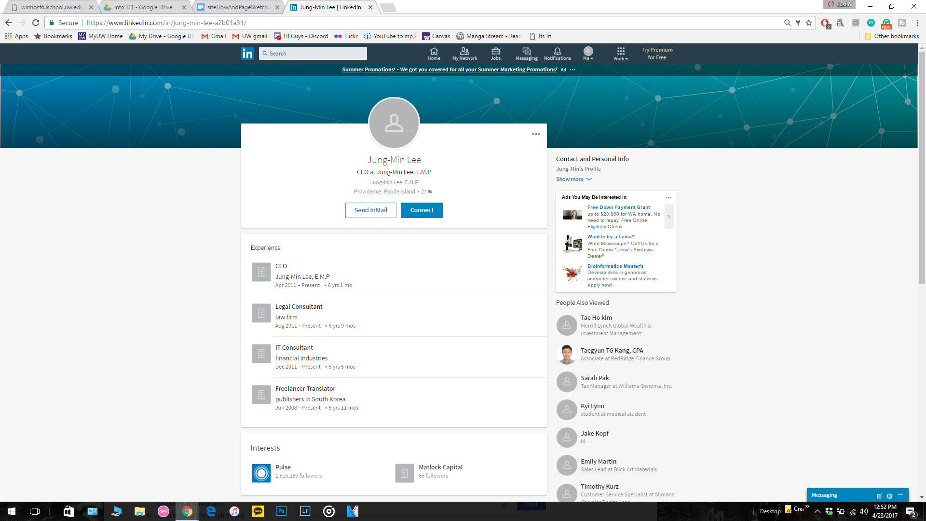

#### Page where you get an answer

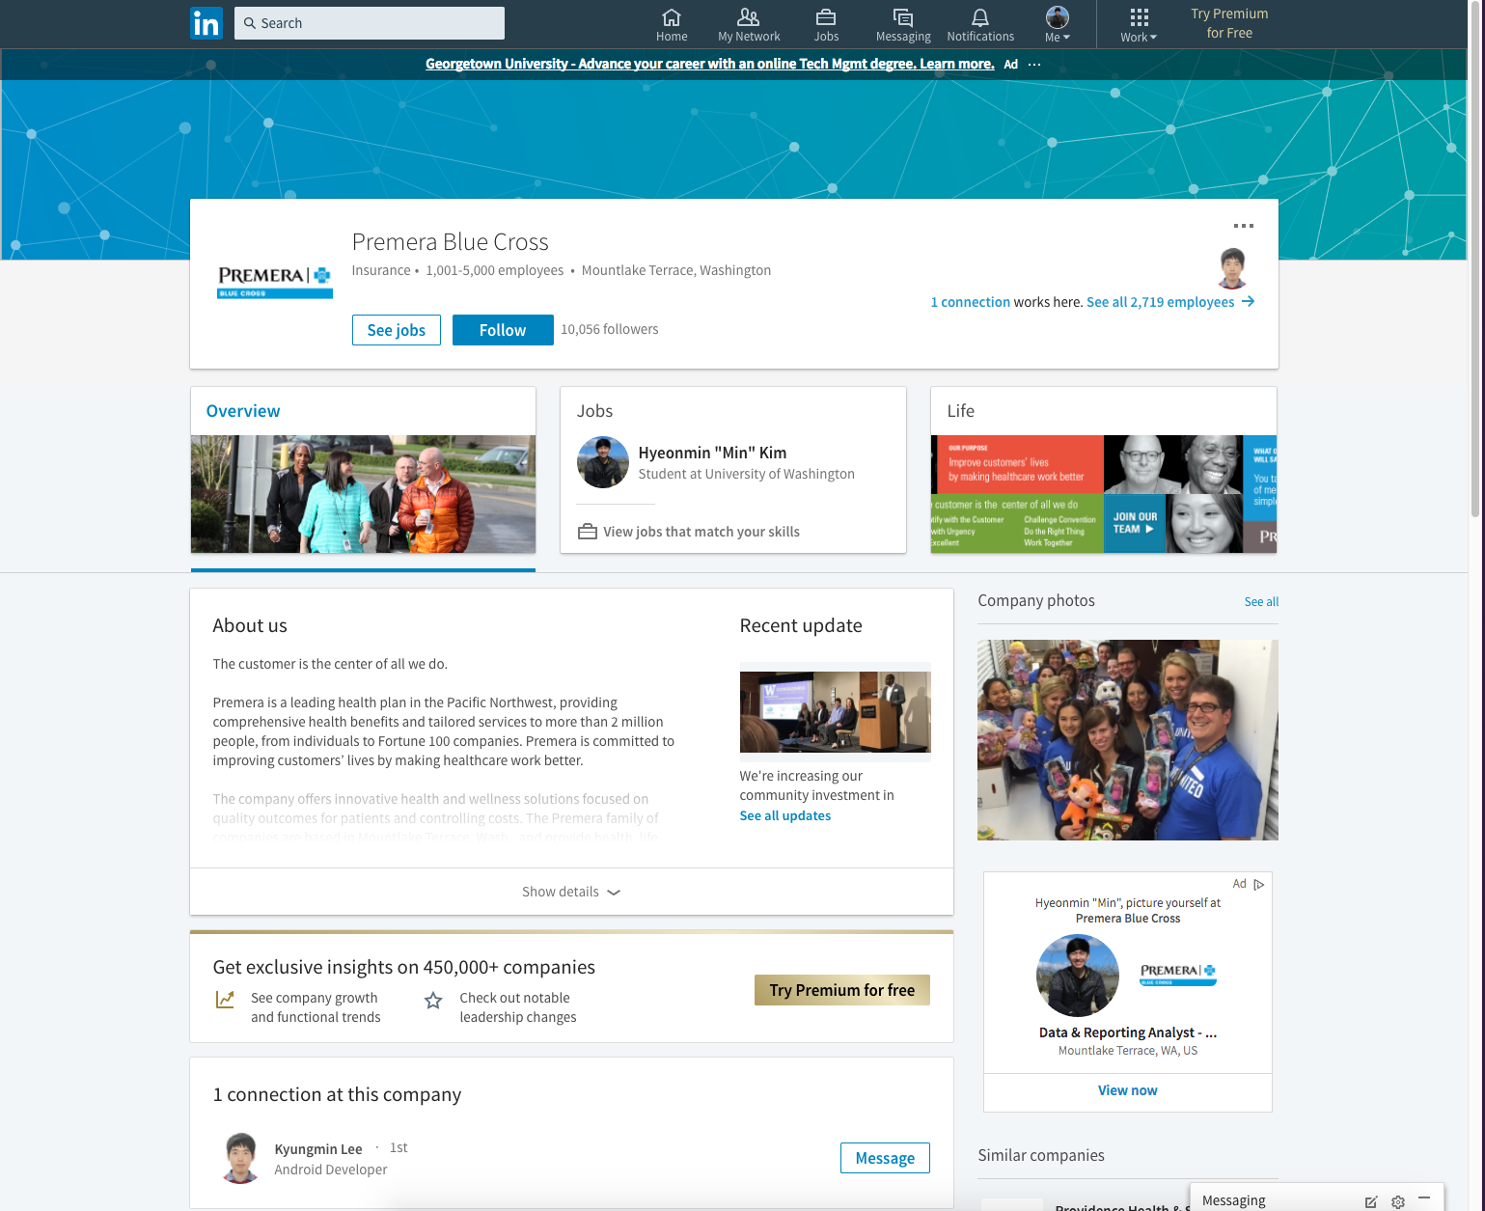

## Step 2: Sketch One Competitor Flow

### Favorite Competitor: Page Flow Sketch

Pages sketched as boxes for the flow between pages (or screens) where you ask “What should I do tonight?”, look for the answer, and get an answer. Arrows drawn between the boxes show how the pages are connected by clicks. Inside the page boxes details include:

* Where you ask the question
* Where the navigation is that allows you to find things to do
* Where the details of the “things to do” are displayed
* Where you click to move from page to page

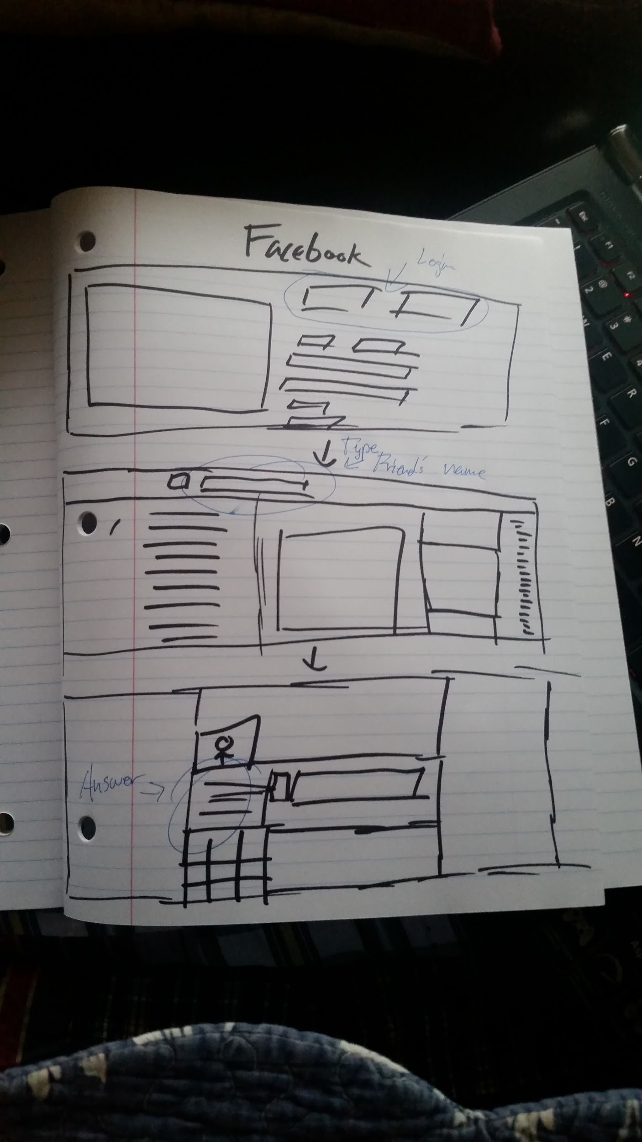

## Step 3: Sketch YOUR Flow

### My Site Name

<ListComp>

#### Sketch of My Page Flow

Pages sketched as boxes for the flow between pages (or screens) where you ask “get a list of company that your friends are working?”, look for the answer, and get an answer. Arrows drawn between the boxes show how the pages are connected by clicks. Inside the page boxes details include:

* Where you ask the question
* Where the navigation is that allows you to find things to do
* Where the details of the “things to do” are displayed
* Where you click to move from page to page

<paste screenshot of sketches here>

#### Page (or Screen) where you ask “find which company has most of your friend working”

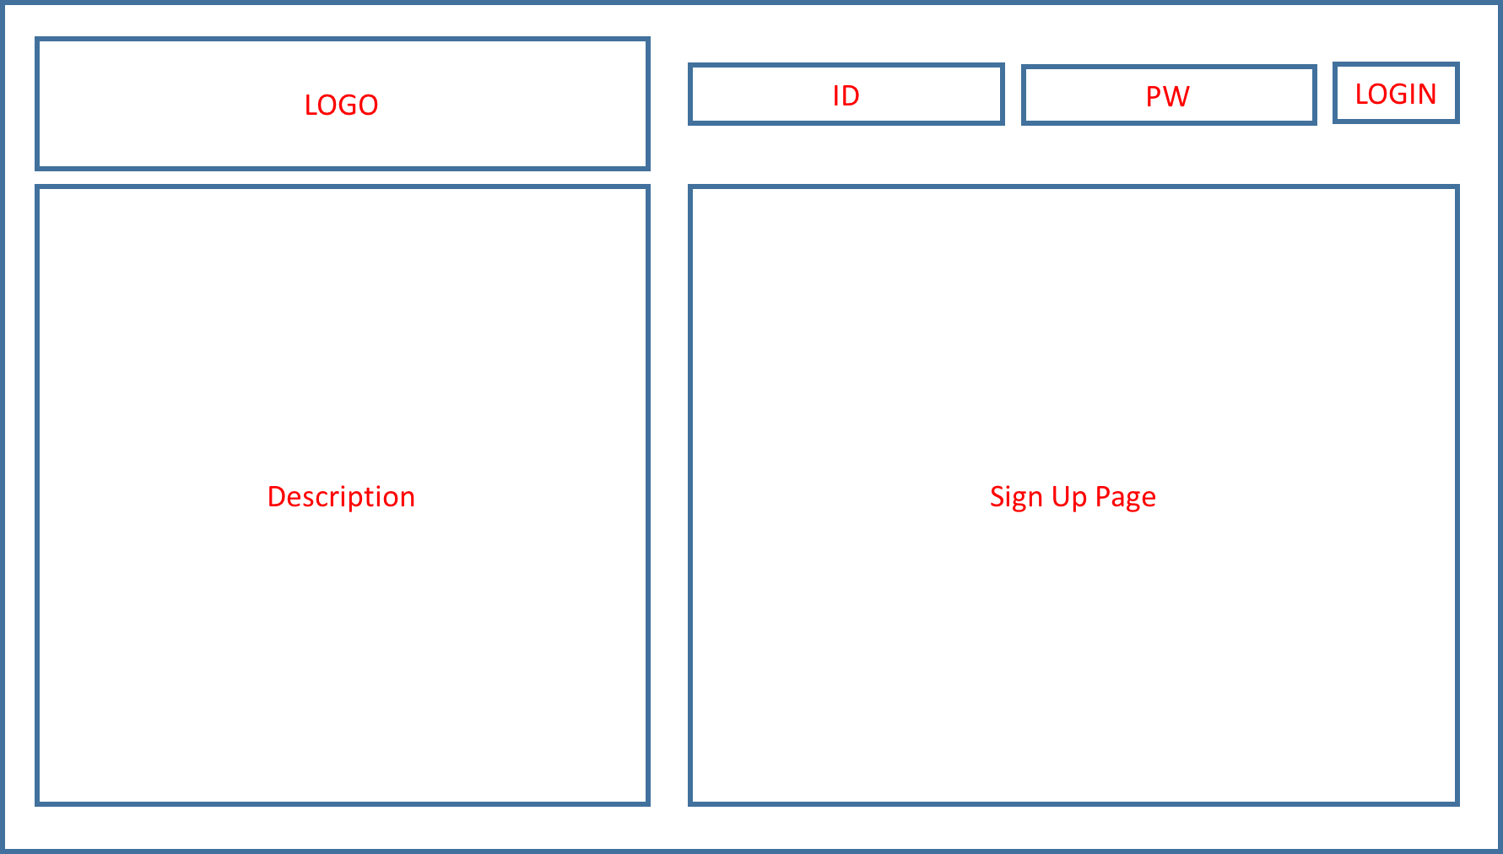

* User’s going to login in order to use the service

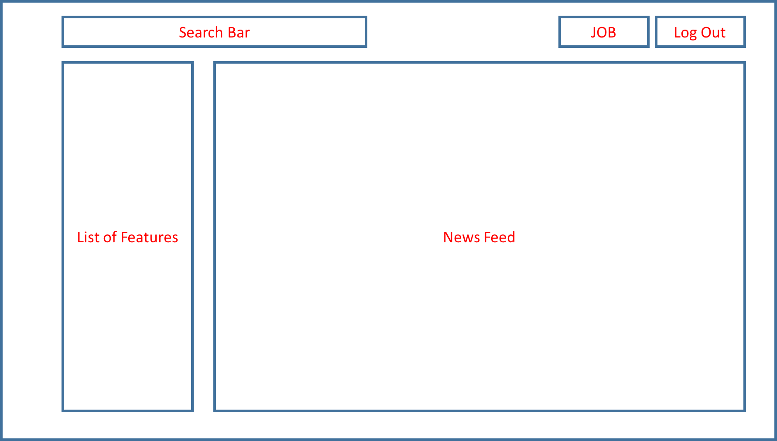

* After logging in, users going to see search bar, list of features, news feed, and ‘JOB’ button.
  + search bar: allow users to search for anything
  + list of features: list of features that the web services provides
  + news feed : list of postings that you friends either liked or posted
  + JOB: allow users to go separate link that is about JOB
* In order to answer the question, user is expected to click ‘JOB’

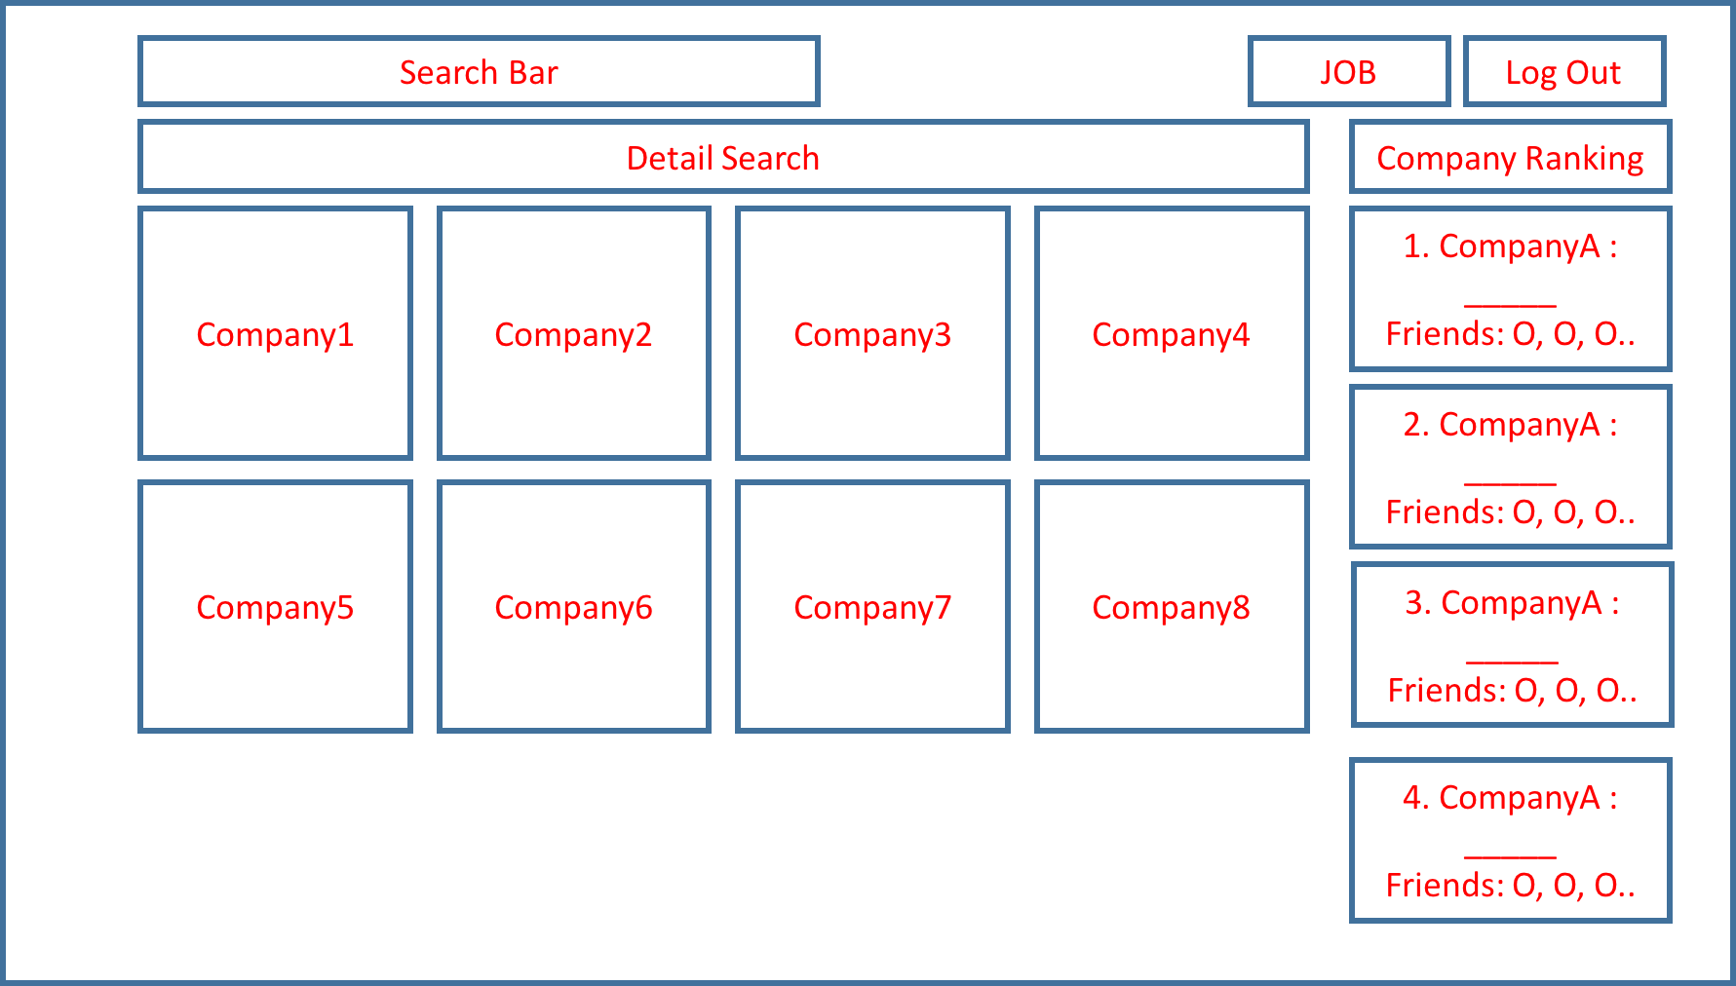

* This is the screen that user see when clicking JOB button.
* it has list of companies that looking for their openings
* right side of the page has list of companies that has your friend is currently working or previously worked.
* In job page, users can not only see the list of company on right side but companies that have openings for the position. Users can apply for the job or share with friends

**User testing**

**Step 1: The Usability Test**

User Feedback: Explain here in detail

1. An easier sign in page
2. A bigger button for jobs so that it seems more significant; put important things on left
3. Too much information on one page, be brief and succinct, information should correspond

**Proposed Changes as a result of feedback**

1. Will make simpler sign in page
2. Will enlarge small boxes
3. Remove unnecessary information

**Step 2: Revision**

Explanation of changes made

1. Users now have an easier way to sign in
2. Users now can access pages with ease
3. Users can find information needed better

Sketch with changes

<paste screenshot of sketches with changes here>

**Step 3: Second Usability Test**

User Feedback: Explain here in detail

1. “Job search/search for jobs” instead of “JOB” — confusing
2. Filter option for search, so only need one search bar
3. drop down menu

Proposed Changes as a result of feedback

1. Will make one search bar
2. Will add filter to search
3. Will change wording so that it is easier to understand

**Step 4: Revision**

Explanation of changes made

1. We combined our search bar into one
2. We titled our search bar “search”
3. We added filter options to the search

<paste screenshot of sketches with changes here>

Sketches with changes

<paste screenshot of sketches with changes here>